**Lab 6: Create a DOM from HTML:**

1. **Ch6 Planets.html:**

This is my final output based on the lecture’s instructions:

For a better look, please check the png image in this github link:

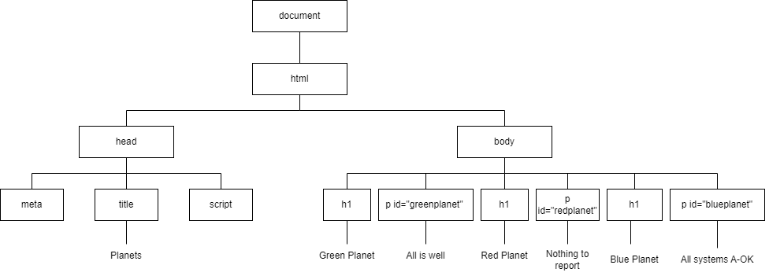

This is output 2 because I was a little bit confused whether to the leave the script branch empty or not since in the provided code, there was a script tag in the head so, I have this output as well.

For a better look, please check the png image in this github link:

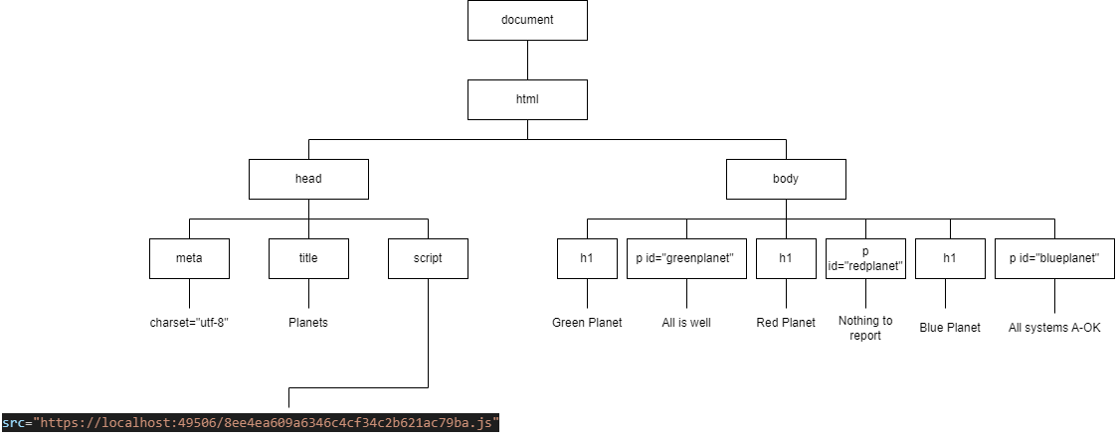

1. **Ch6 Evel.html:**

This is my final output based on the lecture’s instructions:

For a better look, please check the png image in this github link:

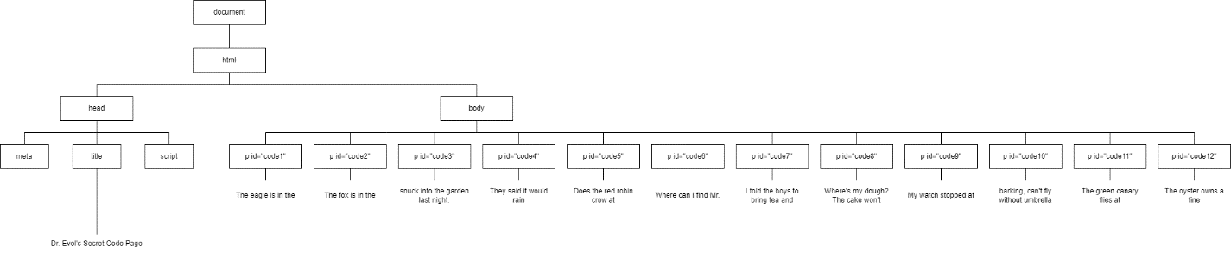

This is output 2 because I was a little bit confused whether to the leave the script branch empty or not since in the provided code, there was a script tag in the head so, I have this output as well.

For a better look, please check the png image in this github link:

